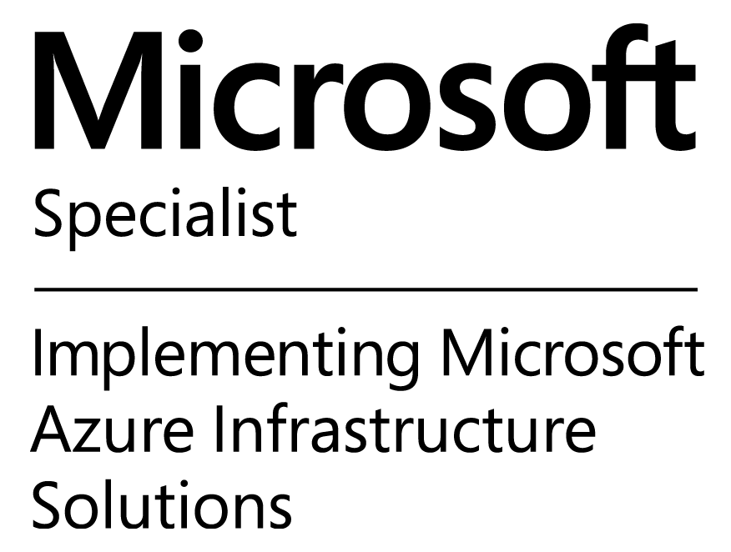

**<Your Name>**

**E-Mail:** <Your Email> <Certifications If any>

**Mobile:** +91-<Cell No>

Seeking a suitable position in a DevOps, AWS, Azure field where excellent analytical problem-solving skill, great interest in the concerned field, relevant knowledge and a strong work ethic can advance Personal and Organization’s growth and gives me a better stability with work-life balance

**PROFILE SUMMARY:**

Having nearly <Your Years of Experience> years of experience in the field of IT where Planning, Implementation, Design, Architecture, Administration, trouble shootings are involved. Having nearly <Relevant DevOps Experience > years of experience on DevOps, AWS, Microsoft Azure, GCP, OpenStack and Cloud Computing.

**IT SKILLS:**

**Cloud Platform**: AWS, Azure, OpenStack, GCP

**DevOps Tools**: Jenkins, GIT, Docker, Docker Swarm, Kubernetes, Nagios, Splunk, Ansible, Maven, Jira, Chef.

**Operating System**: Linux, Centos, Ubuntu, Redhat Windows

**Language**: YAML, NodeJS,

**CERTIFICATIONS and TRANINGS:**

* <Your Certification If Any>
* EX: AWS Certified Solution Architect
* EX: Azure Solution Architect

**ORGANISATIONAL EXPERIENCE:**

**<Duration> - Till date with <Your Company Name> as <Your Designation>.**

Major Project:

* Implementing DevOps CI and CD process using open source tools.
* Working on AWS and Azure Cloud.
* Provisioning, managing and Administration of Cloud based resources.
* Working on Jenkins, Ansible, Chef, Docker, Kubernetes, Git, GitHub, Nagios, Splunk and Jira.
* Delivery of services such as Technical Guidance, presentations, skills transfer, code samples, architecture planning/guidance, code reviews, DevOps and ALM aspects to partners and customers using AWS, Microsoft Azure cloud technologies.
* Jenkins as a primary tool for implementing the continuous integration and continuous delivery of their code releases
* Docker container creation and management, Docker file management, deploying micro services to Docker container.
* Managing and monitoring container using Docker Swarm and Kubernetes.
* Server configuration management via Ansible and Maintained environments deployed.
* Created Ansible playbooks for the Deployment and Infrastructure automation purpose
* Configured Auto scaling policies and configuration for the Production Environment
* AWS and Azure instance creation to support the testing environments like IT, UAT and MNT
* Controlled the user access to multiple s3 buckets using bucket polices
* Implemented a Sonar software quality testing metrics server. Sonar testing metrics executed as a built-in Jenkins plug-in to assist in quality build testing metrics. Developed Sonar blocker violation profiles to report build failures expeditiously to the build and development team.
* Working with development team on enforcing source control strategies, building, packaging and deployment of products.
* Create GitHub projects for developers to store the code and managed the user access
* Have worked on Nagios and Splunk tool to fix AWS and Azure VM related issues

**<Duration> with <Your company Name> as <Your Designation>**

Major Project:

* Have Worked on AWS and Microsoft Azure Cloud, helped many AWS, Azure customers on Architecture Design of cost effective scalable Cloud based solutions using IAAS/PASS models.
* Jenkins as a primary tool for implementing the continuous integration and continuous delivery of their code releases
* GIT Hub as code repository and versioning.
* Worked closely with the field teams and other teams in TCS to help them understand the partner technical services team and also to looks at various ways on how to collaborate effectively with the Partner Technical Services team.
* Helped customers in all phases of SDLC related to Azure RDS, focusing on conceptualizing business needs and translating them into viable technical solutions.
* Managing the relationship with the customer/partner’s technical team across all the region.
* Handle escalated Support tickets till closure for MS Azure and AWS.
* Provisions and management of instances though JSON Template, PowerShell, CLI Re-Creation of instances using PS, Scale up/down of VMs. Changing Cloud Service with minimal Downtime. Removal and Deletion of VMs. RDS setup and configuration.
* Have worked on database services AWS S3, AWS RDS, Dynamo DB, Azure Storage account and Azure SQL management.
* Virtual Network - Creation and configurations of VNET and Subnets, Express Route, AWS VPC, VNET and VPC Peering. OMS as monitoring tool form Azure VMs
* Cloud Service - configuration of High Availability using cluster Creation of Endpoints Understanding of Fault Domain / Update Domain RDS Rolls Installations
* Cloud Security - NSG and AWS Security Group setup and configuration, Multi factor authentication.
* Network monitoring using AWS cloud Watch, Splunk. Alien Vault.
* AWS ECS, IAM, AWS SQS, Cloud Trail, SES, SNS, AWS static website creation.
* Have worked on AWS Cloud Formation to create environment, AWS Cloud front.

**<Duration> with <Your Company Name> Pune as <Your Designation>**

Major Projects:

<Your Project Summary>

**<Duration> with <Your Company Name> Pune as <Your Designation>**

Major Projects:

<Your Project Summary>

**EDUCATION**

* Your Education Details

**PERSONAL DETAILS**

Date of Birth: <Date of Birth>

Address: <Address>

Languages Known: <Known Language>

<Location> <Your Name>